William Colon

3-2 Milestone Two

Enhancement One: Software Design and Engineering

This Artifact I selected from one of my previous classes CS-320 Software Development Life Cycle is about making an appointment, I decided to use c++ 1st because I’m not a developer I don’t have much experience in coding and 2nd the best instructions I found was for C++ at least for me. I’ve worked on this code for a while at first the personal information you have to write it directly in the code but after a lot of reading and videos I worked and created a function that when you run the code the program asks for the information one at time, I created my eporfolio and uploaded it to it, to be able to demonstrate my knowledge in C++ and object-oriented programming, I’m planning to add the capabilities to save all the data to a database, but I haven’t figure it out that yet. I believed I have accomplished the course objectives I had planned since the beginning. Reflecting on the method of modifying and enhancing my artifact. Been able to see things from afar has been beneficial in my learning process, as I can now see them from an even more distant perspective.

First the info was embedded in the code 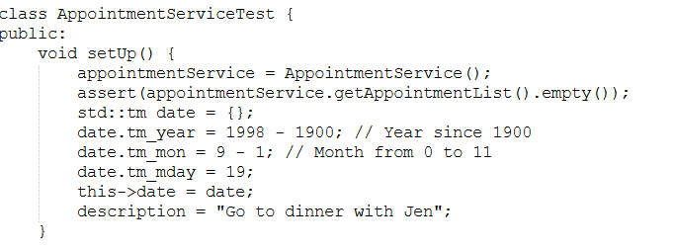

I added the function so the program asks for the information

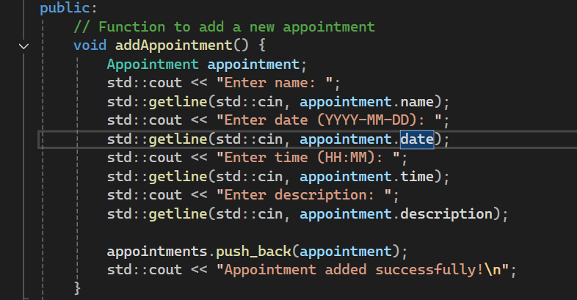

This function will display any previews appointment 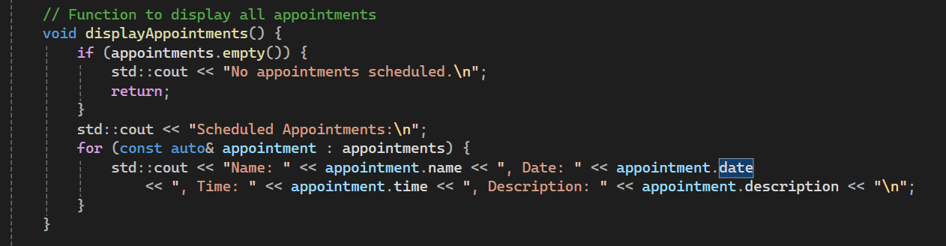

With this one you can delete all the previews appointments.

